

**Hospitality**

PRESENTED BY

FUTURESHAPERS

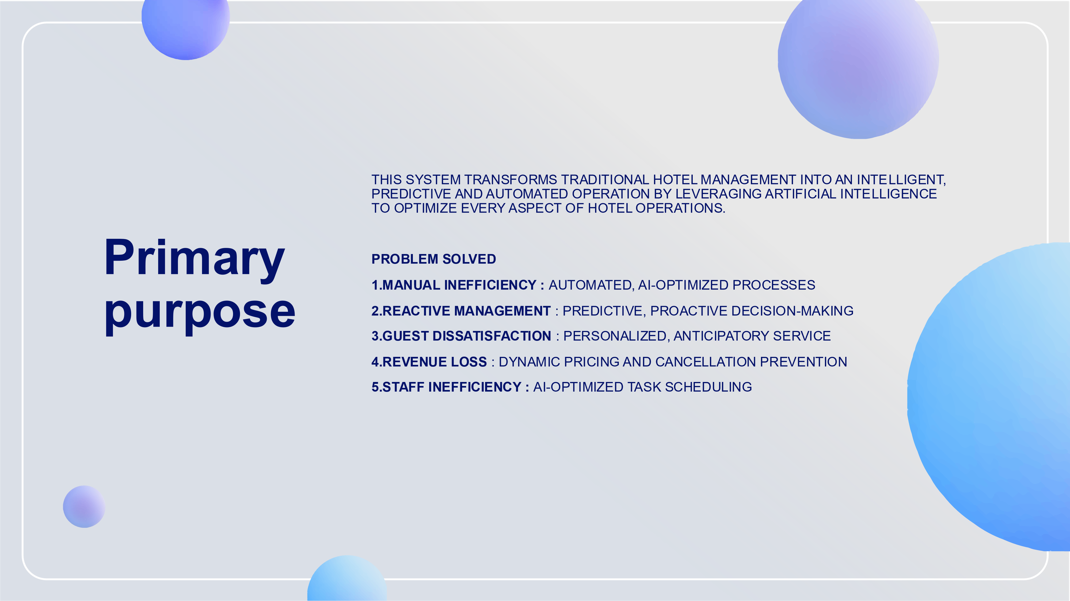



**TECHNOLOGY STACK**

**AI ENGINE**

-

PYTHON 3.8+ WITH SCIKIT

-

LEARN, PANDAS, NUMPY

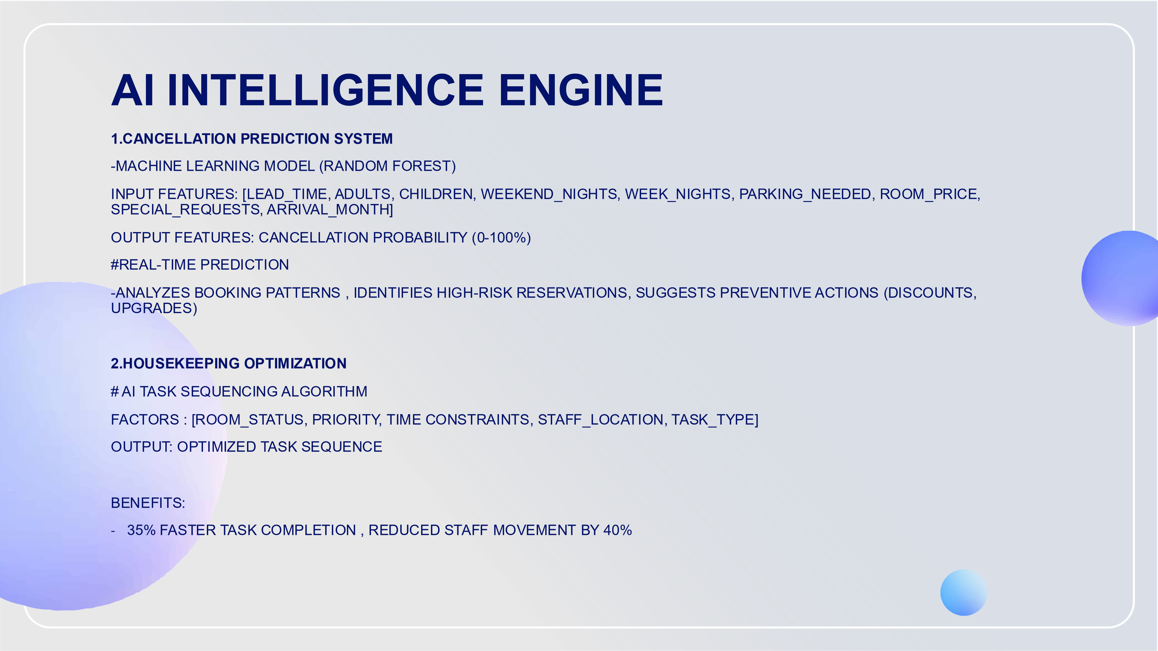



**GUEST VALUE SCORING**

**DYNAMIC PRICING ENGINE**

**-**

ANALYZES HISTORICAL OCCUPANCY DATA

-

CONSIDERS SEASONALITY, EVENTS, COMPETITION

-

SUGGESTS REAL

-

TIME PRICE ADJUSTMENTS

-

IDENTIFIES UPSELL OPPORTUNITIES

**SYSEM OPERATION FLOW**

**RESERVATION PROCESS**

**1**

**.GUEST BOOKING :**

SYSTEM CAPTURES 20+ DATA POINTS

**2**

**.AI RISK ASSESSMENT :**

PREDICTS CANCELLATION PROBABILITY

**3**

**.ROOM ASSIGNMENT:**

AI SUGGESTS OPTIMAL ROOM BASED ON GUEST PREFERENCES

**4**

**.UPSELL RECOMMENDATIONS :**

AI SUGGESTS UPGRADE/AMENITIES

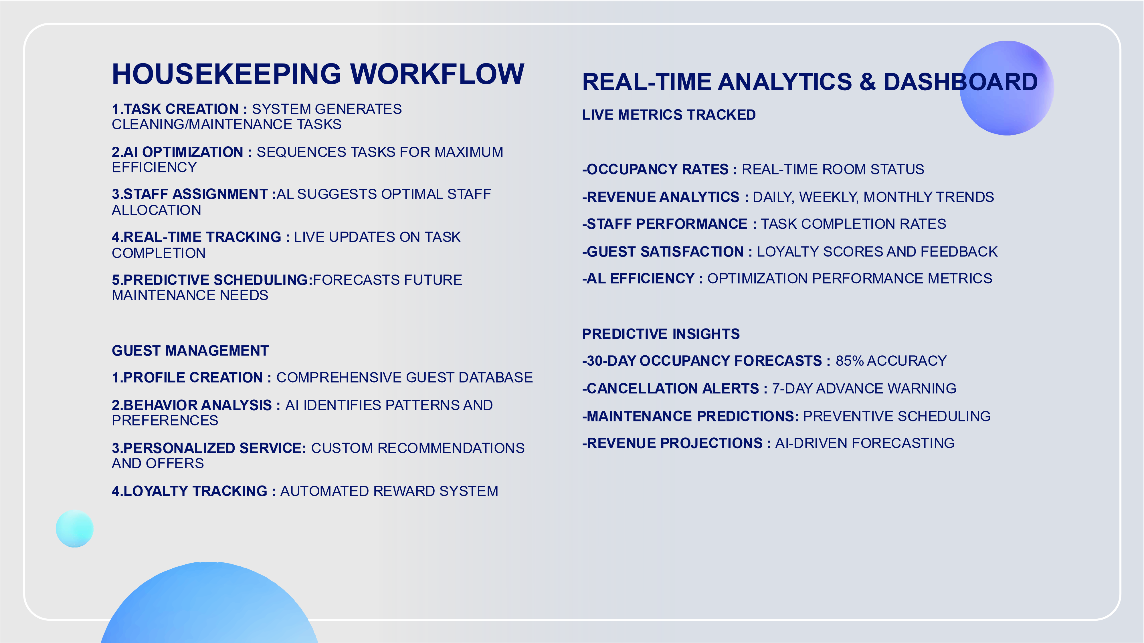



**KEY AI FEATURES & THEIR IMPACT**

**1**

**.SMART CANCELLATION PREVENTION**

**BEFORE AI :**

12

% CANCELLATION RATE, REACTIVE RESPONSES

**AFTER AI:**

6

% CANCELLATION RATE, PROACTIVE INTERVENTIONS

// AI IDENTIFIES

HIGH

-

RISK BOOKINGS

IF ($CANCELLATION_PROBABILITY > 0.7) {

TRIGGER_PREVENTIVE_ACTIONS() ; // DISCOUNTS, PERSONAL CALLS, UPGRADES

}

**2**

**.AUTOMATED HOUSEKEEPING**

**BEFORE AI:**

MANUAL SCHEDULING, 45

-

MINUTES AVERAGE TASK TIME

**AFTER AI:**

AI

-

OPTIMIZED SEQUENCING, 28

-

MINUTE AVERAGE TASK TIME

# AI CALCULATES OPTIMAL TASK SEQUENCE

OPTIMIZED_TASKS = SORT_BY_PRIORITY_SCORE (TASKS)

#RESULTS: 35% TIME SAVINGS, 40% REDUCED STAFF MOVEMENT

**3**

**. INTELLIGENT GUEST PROFILING**

**BEFORE AI :**

GENERIC SERVICE, LOW PERSONALIZATION

**AFTER AI :**

HYPER

-

PERSONALIZED EXPERIENCES, 25% HIGHER SATISFACTION

--

AI GUEST SEGMENTATION

VIP_GUESTS = TOTAL_STAYS >= 3 AND AVG_SPEND > 150

AT_RISK_GUESTS = LAST_VISIT > 180 DAYS AND TOTAL_STAYS > 1

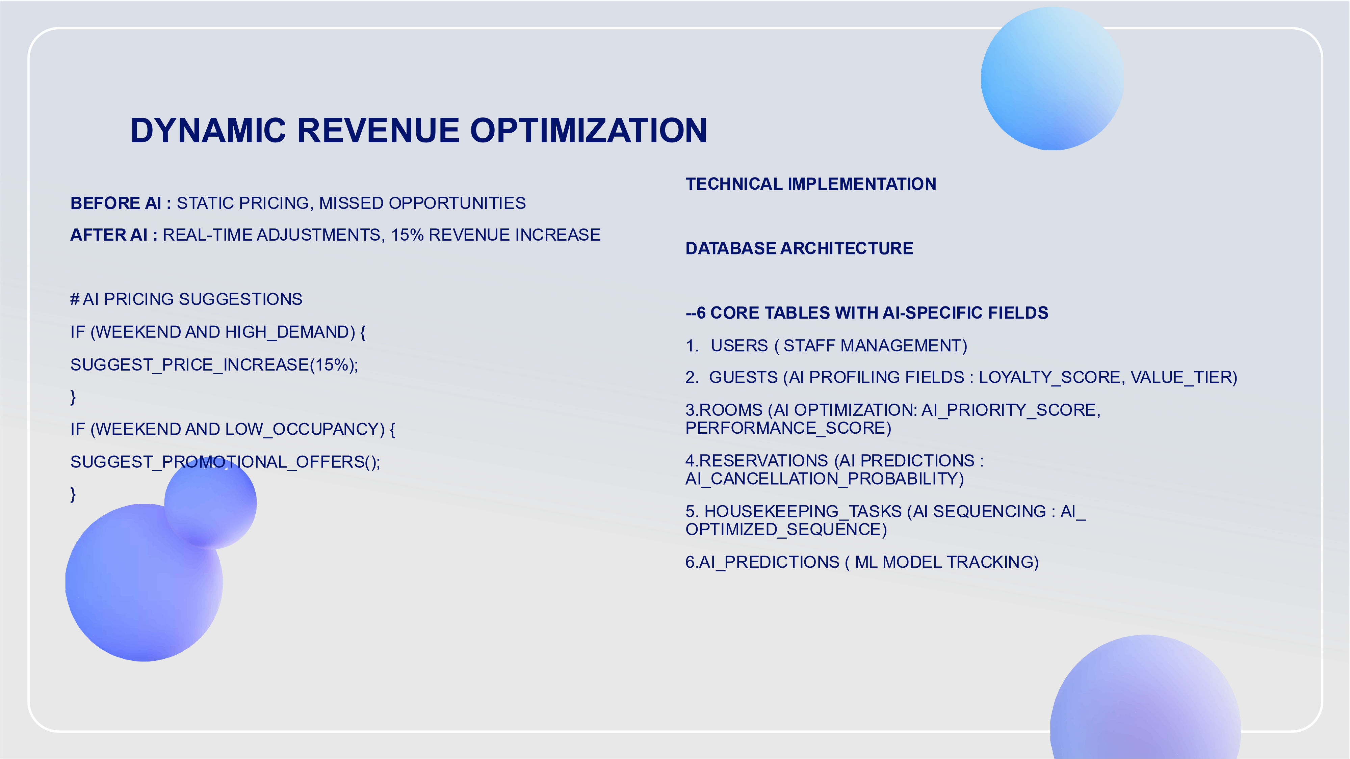

**BUSINESS IMPACTS & ROI**

**QUANTIFIABLE BENEFITS**

**1**

**.REVENUE INCREASE :**

15

-

25

% THROUGH DYNAMIC

PRICING AND REDUCED CANCELLATIONS

**2**

**.COST REDUCTION :**

% IN HOUSEKEEPING LABOR

35

COSTS

**3**

**.GUEST SATISFACTION :**

% IMPROVEMENT IN GUEST

25

EXPERIENCE SCORES

**.STAFF EFFICIENCY :**

**4**

% REDUCTION IN

40

ADMINISTRATIVE TASKS

**.OCCUPANCY OPTIMIZATION :**

**5**

10

-

% BETTER ROOM

15

UTILIZATION

**OPERATIONAL IMPROVEMENTS**

**-**

**FASTER CHECK**

**-**

**INS :**

AI

-

PREPARED ROOM ASSIGNMENTS

-

**PREDICTIVE MAINTENANCE :**

REDUCED ROOM DOWNTIME

**-**

**PERSONALIZED MARKETING :**

HIGHER CONVERSION RATES

**-**

**DATA**

**-**

**DRIVEN DECISIONS :**

REDUCED GUESSWORK IN MANAGEMENT

**SECURITY AND RELIABILITY**

**DATA PROTECTION**

**-**

ENCRYPTED USER SESSIONS

-

SQL INJECTION PREVENTION

-

SECURE AI MODEL EXECUTION

-

REGULAR BACKUP SYSTEMS

**SYSTEM RELIABILITY**

**-**

REDUNDANT DATABASE CONNECTIONS

-

ERROR HANDLING AND LOGGING

-

PERFORMANCE MONITORING

-

AUTOMATED FAILOVER PROCEDURES



**COMPETITIVE ADVANTAGES**

**1**

**.FULLY INTERGRATED AI :**

NOT JUST ANALYTICS

–

ACTUAL OPERATIONAL AI

**2**

**. REAL**

**-**

**TIME OPTIMIZATION :**

LIVE ADJUSTMENTS BASED ON CURRENT CONDITIONS

**3**

**. PREDICITIVE CAPABILITIES :**

ANTICIPATES PROBLEMS BEFORE THEY OCCUR

**4**

**.SCALABLE ARCHITECTURE :**

GROWS WITH HOTEL NEEDS

**5**

**. USER**

**–**

**FRIENDLY INTERFACE :**

COMPLEX AI MADE SIMPLE FOR STAFF

**TARGET USERS & USE CASES**

**PRIMARY USERS**

**-**

**HOTEL MANAGERS:**

STRATEGIC DECISION

-

MAKING

**-**

**FRONT DEST STAFF :**

DAILY OPERATIONS AND GUEST SERVICE

**-**

**HOUSEKEEPING SUPERVISORS:**

STAFF COORDINATION AND TASK MANAGEMENT

**-**

**REVENUE MANAGERS :**

PRICING AND OCCUPANCY OPTIMIZATION

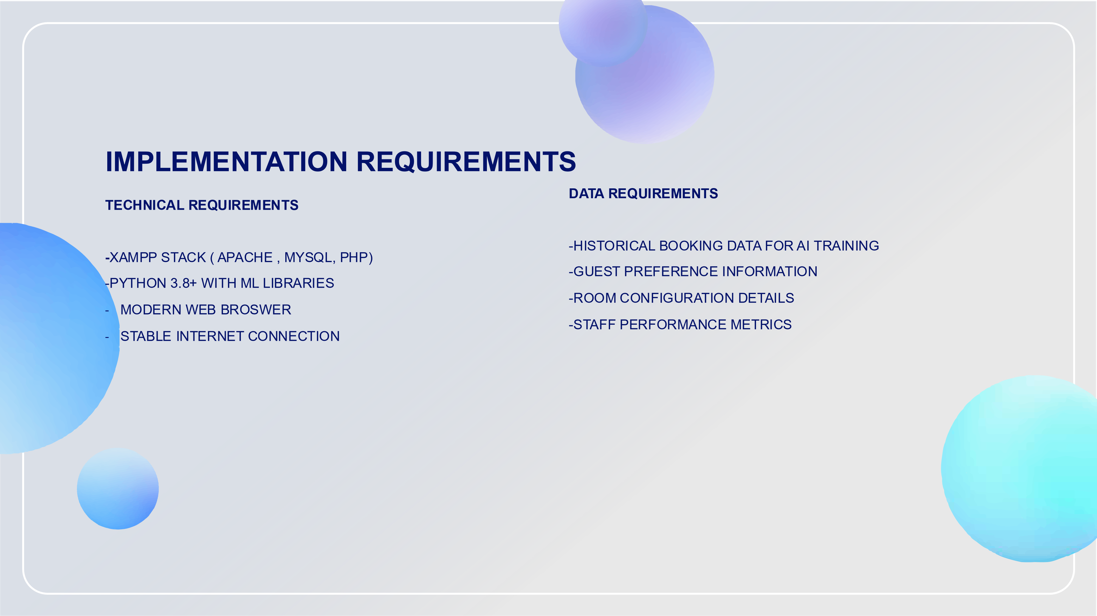



**THANK YOU**

-

FUTURESHAPERS